Practical 2:
Semantic HTML5 Pages with Accessibility-Ready Structure
Problem Definition Develop static HTML5 skeletons for at least 10 StudentHub pages such as
Home, About, Register, Login, Dashboard, Events, Profile, Contact,
Admin, FAQ, and Feedback. Use semantic tags and accessibility-friendly
structure.

A.Theory
1. Are semantic tags such as header, nav, main, section, article, aside, and footer used properly?
Answer:
Yes. Semantic HTML tags are used properly to give meaning and structure to the webpage.
- <header> → Top/header part of the page
- <nav> → Navigation links
- <main> → Main content
- <section> → Different sections of content
- <article> → Independent content
- <aside> → Side/extra information
- <footer> → Bottom/footer part of the page

2. Are form labels, headings, image alt text, and navigation links accessible?
Answer:
Yes. Proper <label> tags are used for form fields, headings like <h1>, <h2> are used in correct order, images have meaningful alt text, and navigation links have clear text. This makes the website easier to use for all users, including people using screen readers.

c.Evidence of work(screenshort)
1.home
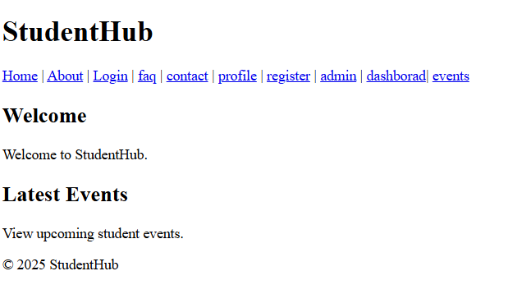
2.login
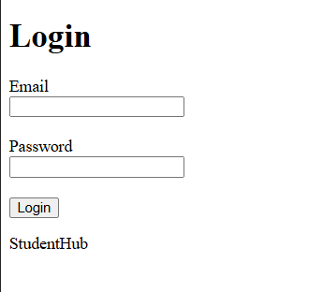

3.about
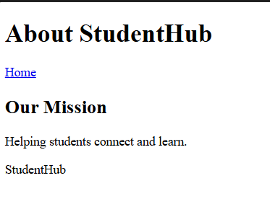
4.registration
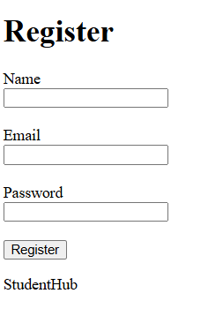

5.dashboard
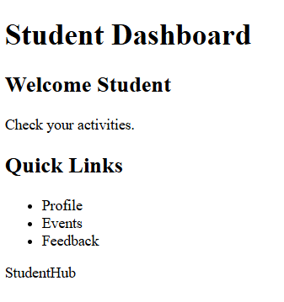
6.event
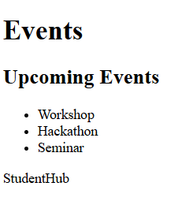

7.profile
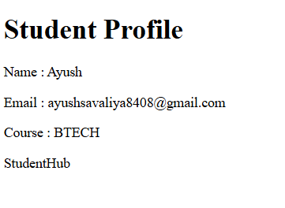
8.contact
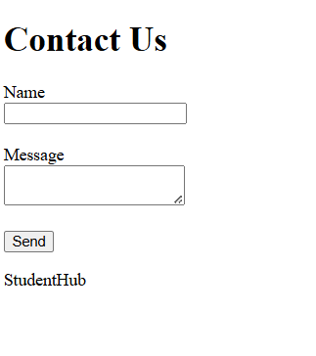

9.FAQ
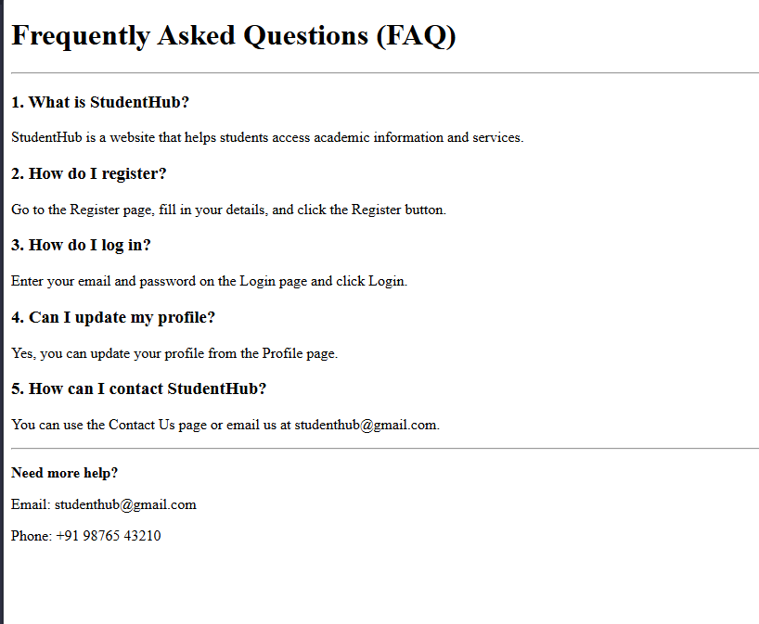
10.Feedback
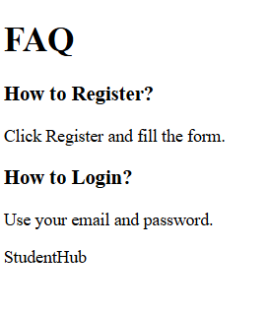

D.github repository link:
https://github.com/Ayushsavaliya0305/25dce104-web
E.challenges Faces:
F.learning outcome:
Page structure — html, head, body
Text & headings — h1–h6, p
Links — a
Images — img
Lists & tables
Forms — form, input, label, button
Semantic tags — header, nav, main, section, article, footer
Accessibility — alt text, labels, proper headings
Facutly Remarks:

